23CSE202 DATABASE MANAGEMENT SYSTEMS
S3 B.Tech CSE
Department of Computer Science and Engineering
Amrita School of Computing, Amritapuri Campus

2. UI Design Document

Group No :C11
Team Members :
Roll No | Student Name
AM.SC.U4CSE25207 | Ayush Kushwaha
AM.SC.U4CSE25237 | Nayantheerth Akhil
AM.SC.U4CSE25246 | Sanjana S
AM.SC.U4CSE25254 | Tejas Shrivastava
AM.SC.U4CSE25256 | Varun Nagnath Lokare

Project Title : RFID-Based Inventory Management System

2.1. Functional requirements:
1. Add, edit, delete, and view products in the inventory (name, category, quantity, reorder threshold).
2. Capture stock-in / stock-out events automatically through RFID tag scans linked to the Arduino RFID reader.
3. Create, track, and update customer/purchase orders through status stages (Pending, Shipped, Delivered).
4. Manage supplier records and view each supplier's order history.
5. Make reports (stock-by-category, stock movement over time).
6. Support role-based access for Staff, Manager, and Admin, including a login screen and an admin panel for user, audit-log, and reorder-threshold management.

2.2. Non functional requirements:
1. Usability - clean, intuitive UI usable by store staff with minimal training.
2. Security - role-based access control restricting sensitive pages (Orders, Suppliers, Reports, Admin) from Staff accounts.
3. Data integrity - RFID scans and manual stock adjustments both update inventory through a consistent, auditable trail.
4. Maintainability - UI code separated into a data layer and a UI layer, so mock data can be swapped for real Java/JDBC API calls without reworking the interface.
5. Performance - dashboard and inventory views should reflect scan-driven stock updates without noticeable delay.

2.3. List of AI tools used for building UI(if any):
1.Claude

2.4. Prompt (if any) :
Sl. No | Name of the tool | prompts
1 | Claude | [Each project team must submit a 300–500 word abstract clearly describing the real-world problem, objectives, proposed database system, intended users, and major functionalities. The proposed project should have sufficient database complexity beyond simple read/write operations, and be feasible within the project duration. The abstract must be written in clear, concise, and original language.]  OKay so here are the details to what we are doing and make the abstract accordingly so our project is based on the inventory management in stores. So there will be java code that has oop strucutre and we will use the normal inventory management things like add products, order products and all that stuff you know the general. Then for the back end we will be using sql for that. And for making something interactive we will be using arduino to interact with the java program to add or remove products. So the arduino will have basic rfid reader and the arduino, which can then be used to add products to the database.
2 | Claude | So we need a frontend for this. Can you make a website for this project. This website needs to take data from the rfid thing. run our code for the inventory thing and make a db. Rn we only need the ui design. But make it so that later we can just connect our codes for rfid and sql and java code. Btw is the java code necessary atp ?
3 | Claude | so i have to add different functionality to this software. Can we make a list of features we need to add to this. Then we can add thosee things to the ui
4 | Claude | Q: Which of these should I build into the UI right now, for submission? (Select all that apply) A: don't make the ui now make a list then we'll add those to the ui
5 | Claude | these are good features. Do normal inventory managment sys have some other features too ?
6 | Claude | add them to the list too and act as a senior web developer specializing in inventory management systems. Based on the comprehensive feature list provided in our conversation history, design a multi-page professional website with a clean, functional UI that avoids AI-like aesthetics. Ensure all features are logically organized across pages while maintaining intuitive navigation and role-based access controls.

2.5. List of files:
Admin.html, app.js, dashboard.html, data.js, inventory.html, login.html, order-detail.html, orders.html, product-detail.html, README.md, reports.html, scan-log.html, styles.css, supplier-detail.html, suppliers.html

2.6. UI Screenshots
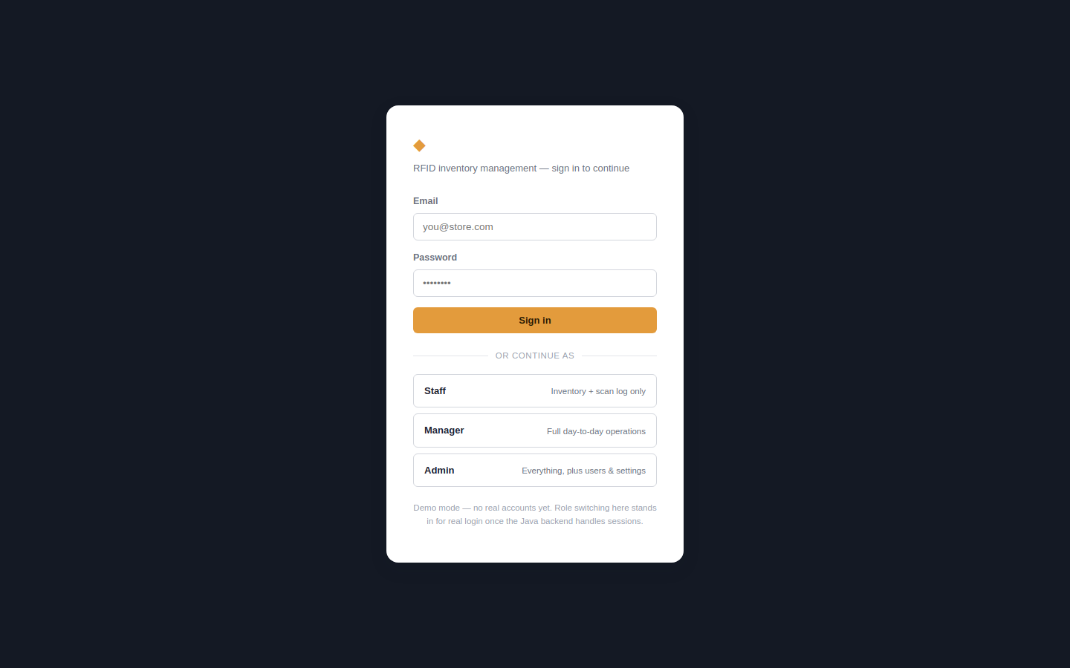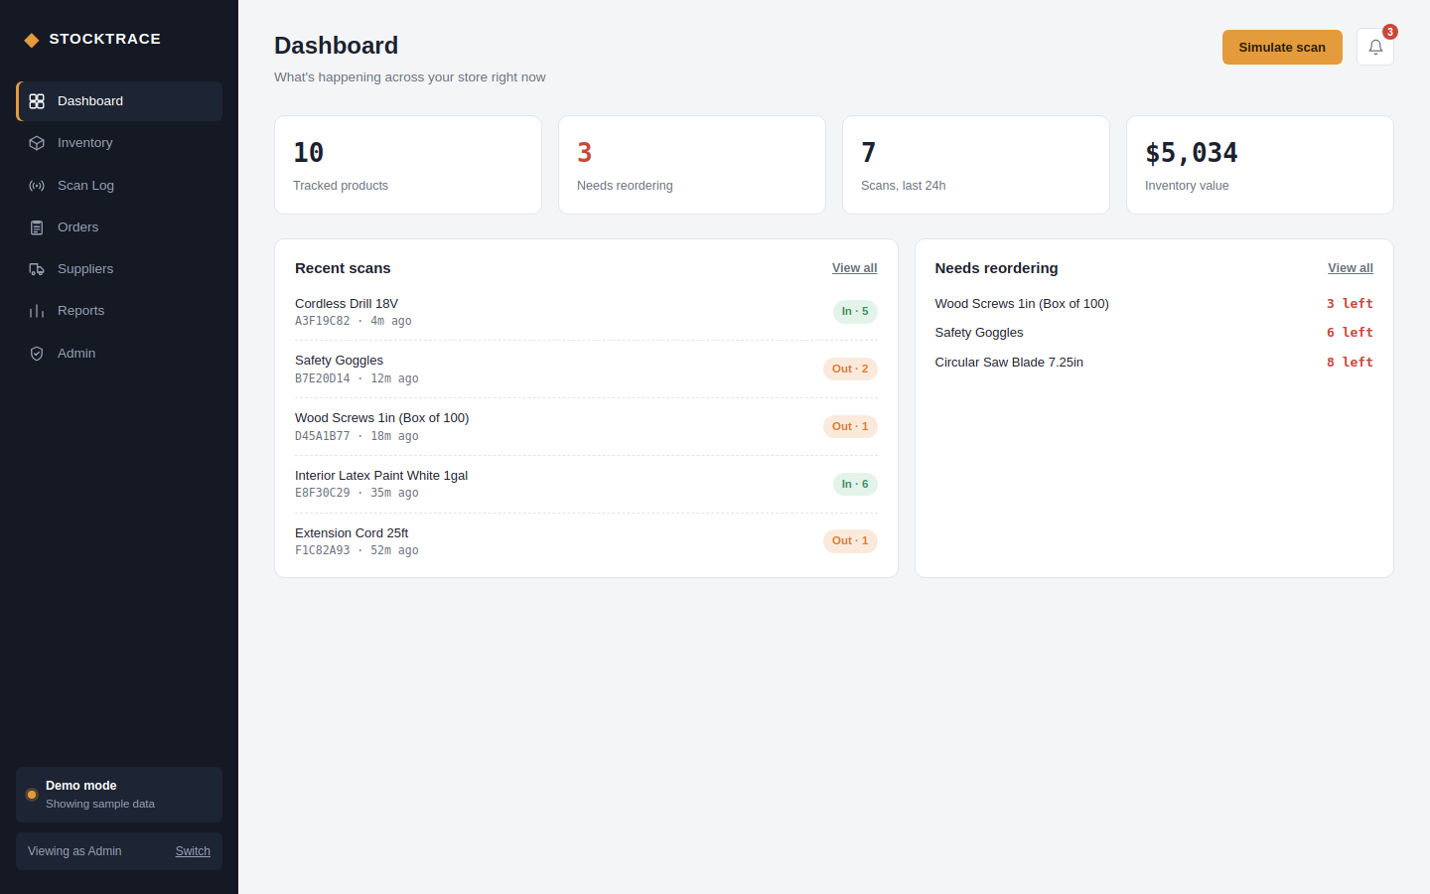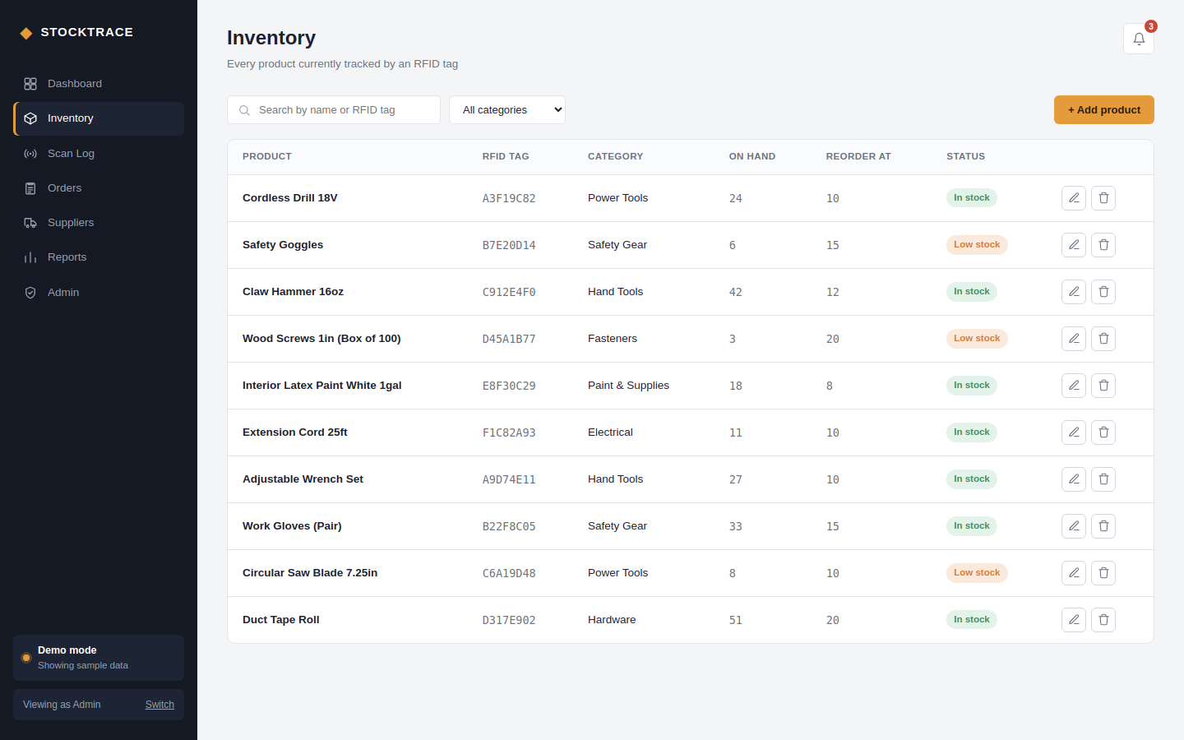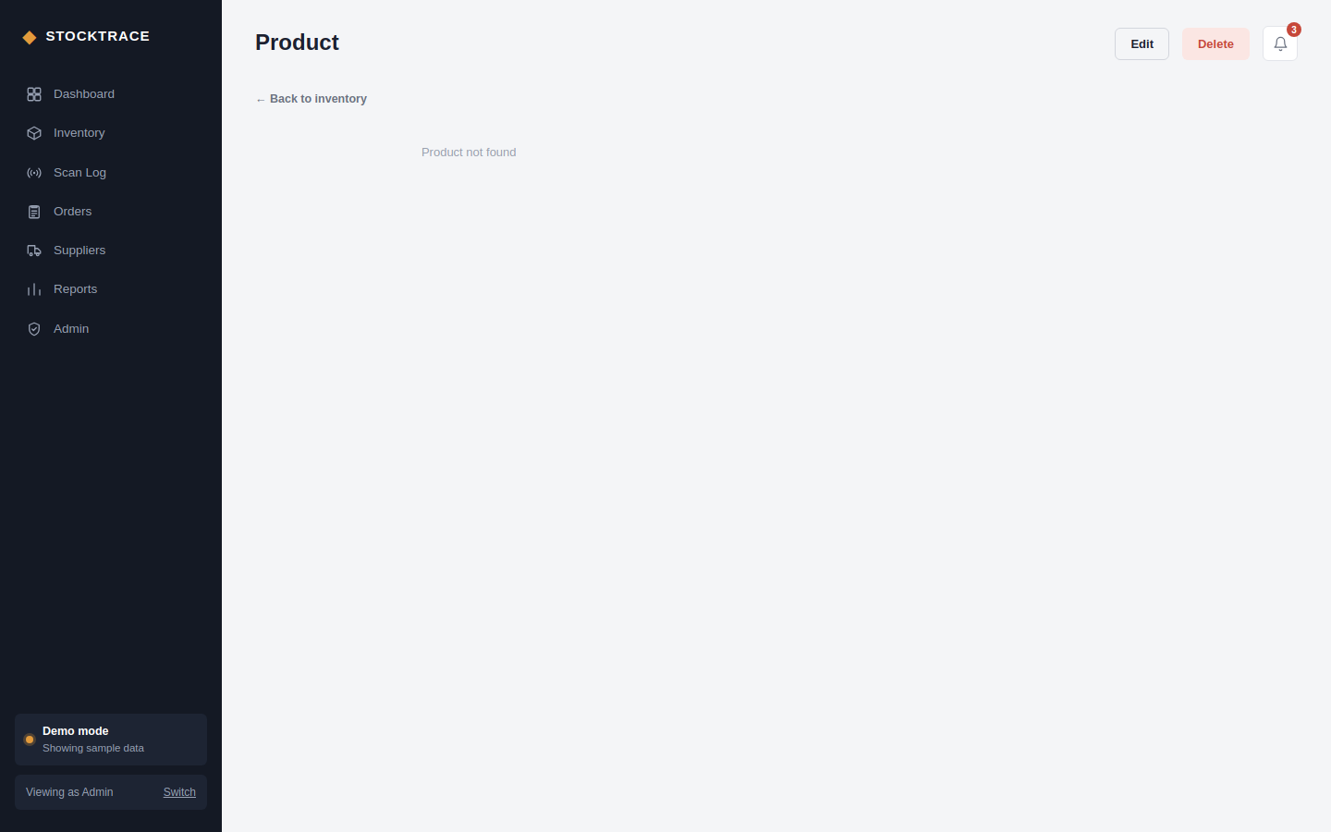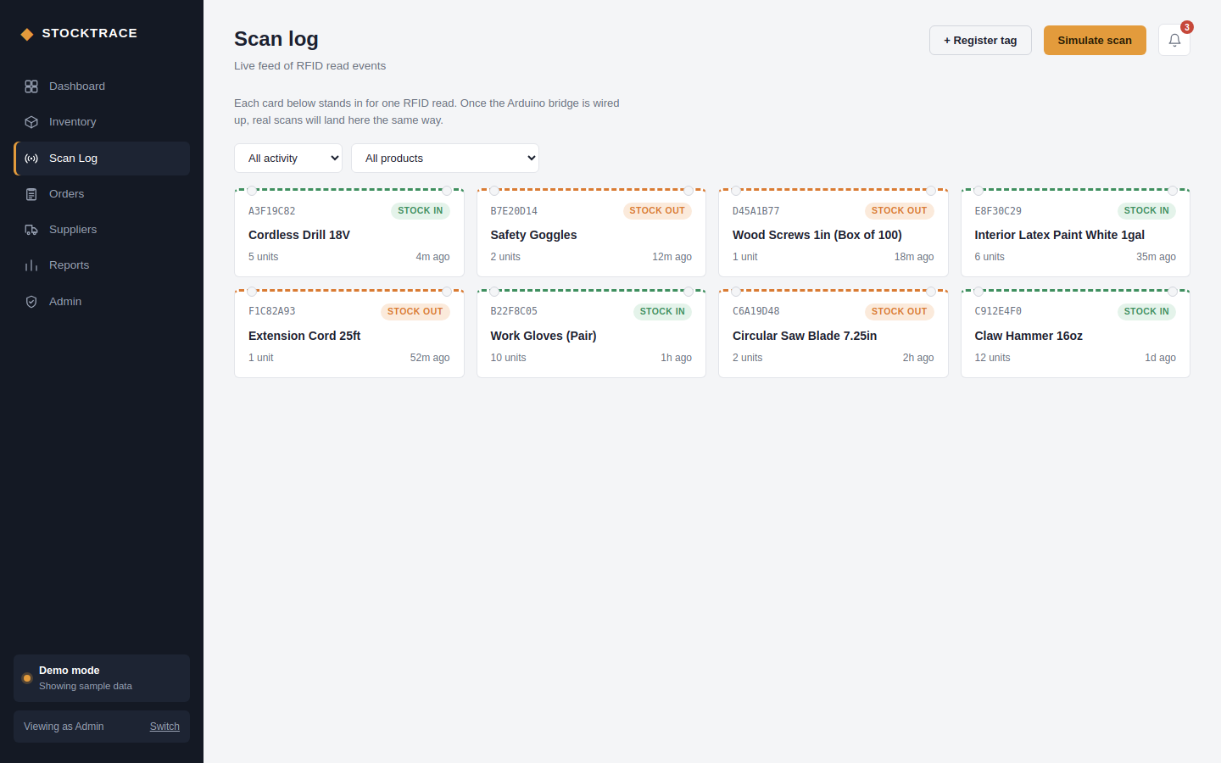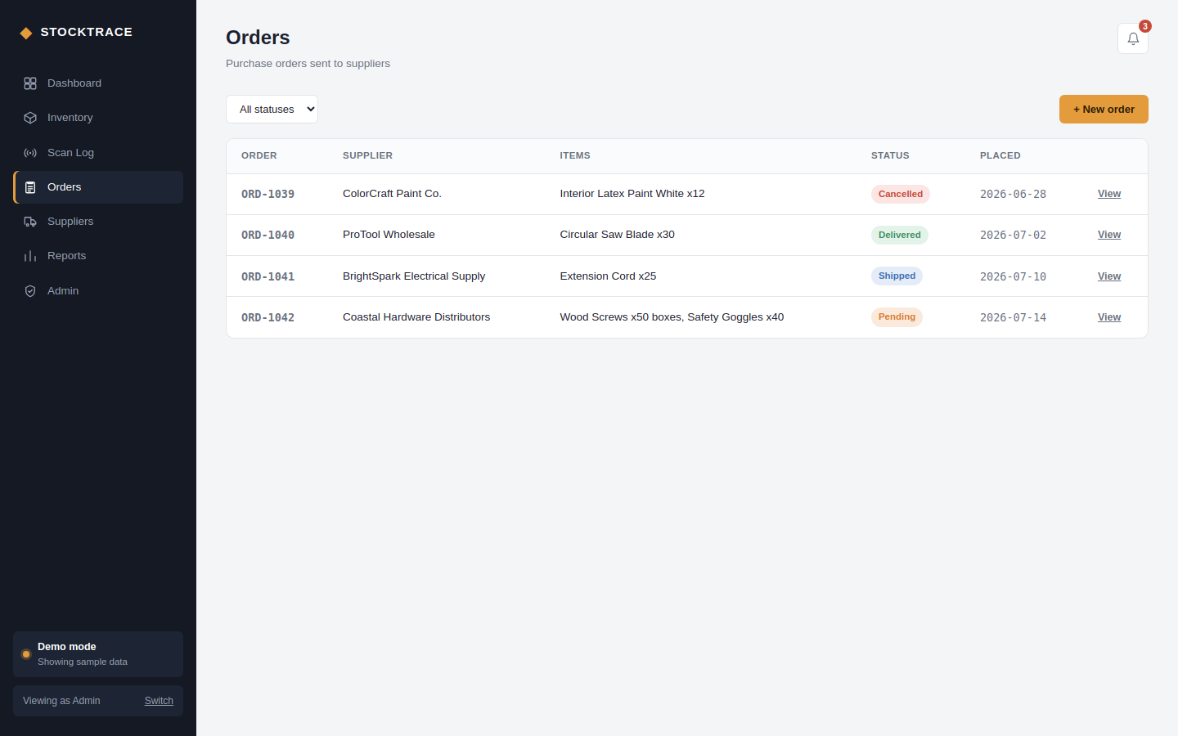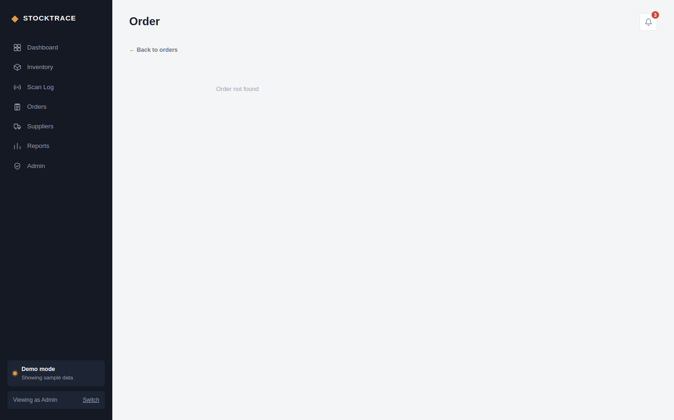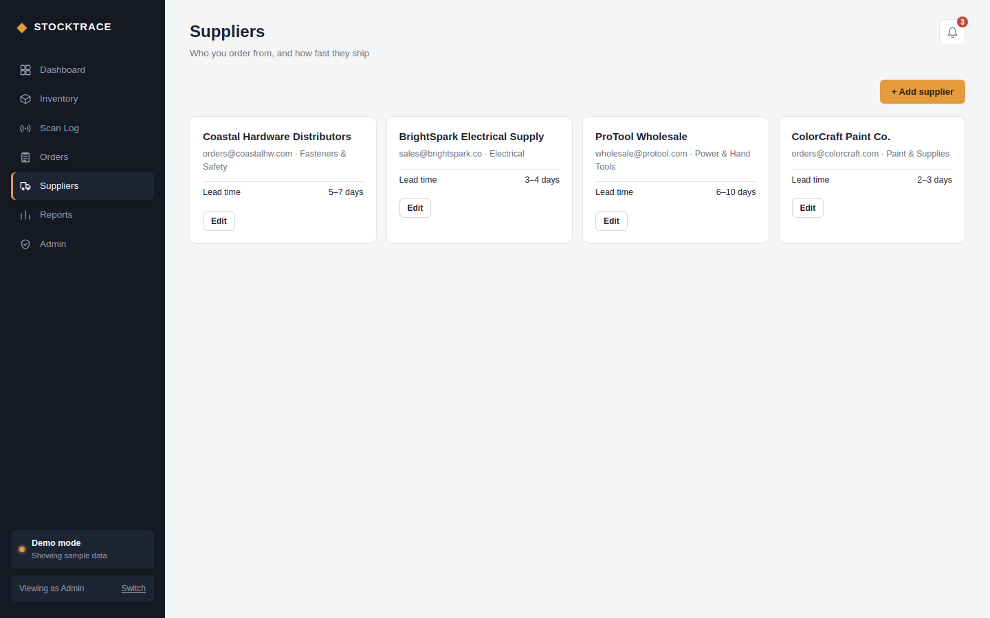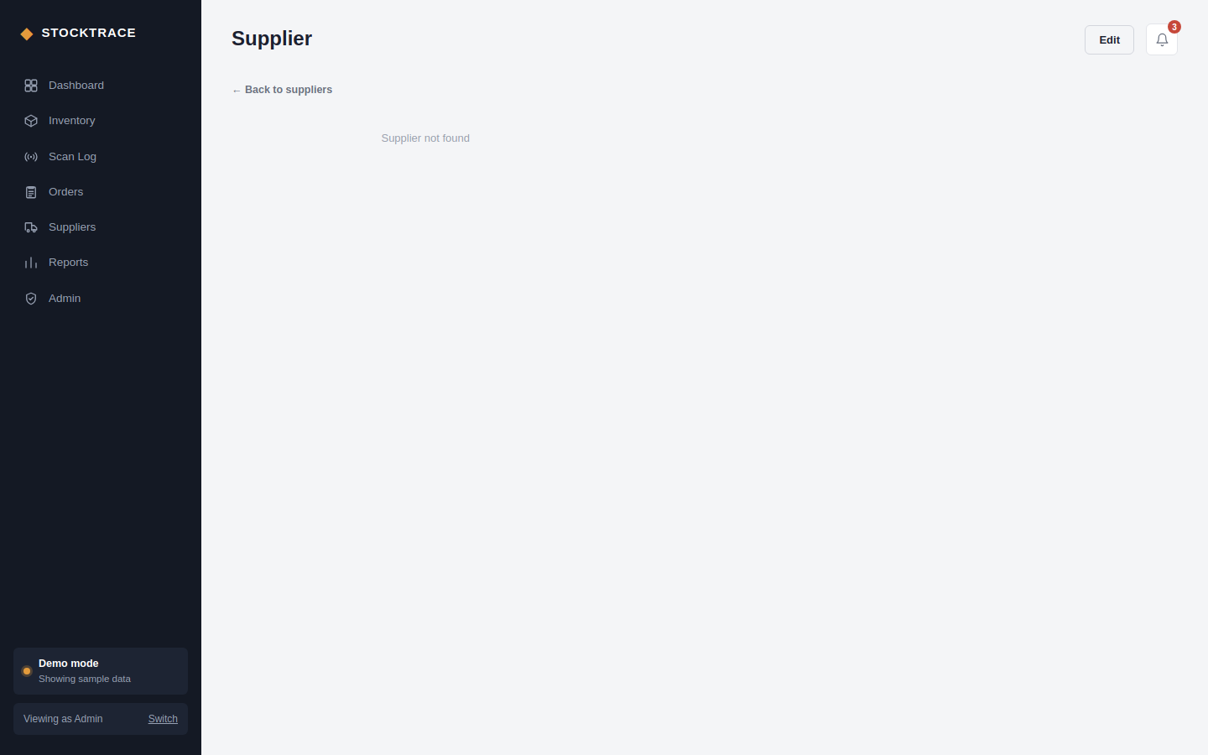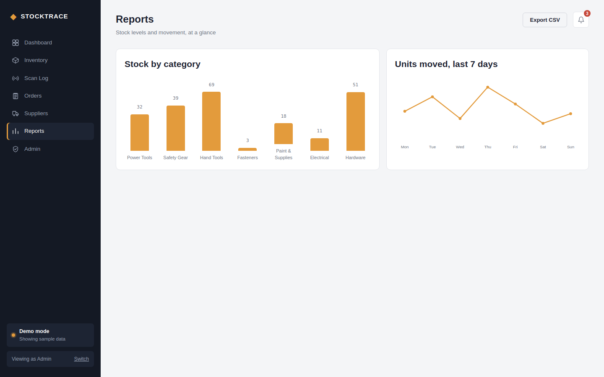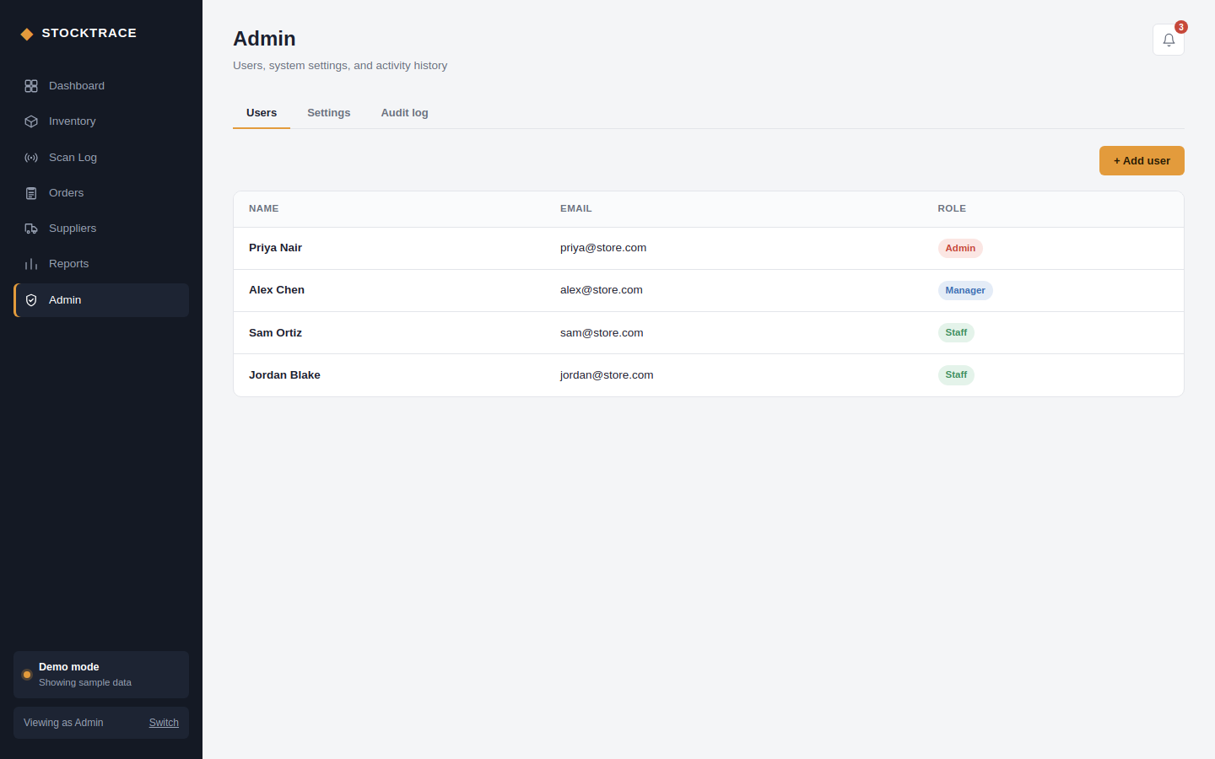

2.7. GitHub Link:
https://github.com/sanjanasaji8121/23CSE202-RFID_Inventory_Management_System

